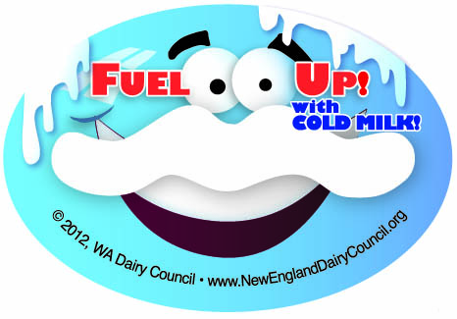
Milk Quality Check List
TIME | TEMP | TASTE  (1=Poor, 5= Excellent)  Complete this survey once a week.  Make sure you are serving your students great tasting ice cold milk!

Check appropriate column:  Either YES, NO or N/A (not applicable in your cafeteria) | YES | NO | N/A

Delivery: Make sure you receive fresh, cold milk.
Do you test milk upon delivery for fresh smell and taste and a temperature between 33° and 41° F? (35° F is ideal)
- Actual temperature on delivery today is ______° F.
Are containers clean and undamaged?
Is the sell-by date far enough in advance to use milk?
Is milk taken to refrigerated storage immediately upon delivery?

Walk-In Cooler/Reach-In Refrigerator Storage:
Keep milk cold and away from other foods.
Is milk rotated, with fresh milk to the back and bottom?
Is milk stored away from all other foods?
(Milk develops off-flavors from other foods, especially produce.)
Is cooler/refrigerator temperature checked and recorded daily?
Is cooler/refrigerator temperature between 33° and 41° F? (about 35° F is ideal)
- Actual temperature today is ______° F.
Are spills wiped up immediately?
Is cooler/refrigerator cleaned regularly?
Is cooler door closed immediately after entering or exiting?
(For every minute door is left open, it takes 18 minutes to bring temperature back down.)

Milk Cooler for Service: Serve milk REALLY cold.

Is milk rotated, with fresh milk to the back and bottom?

Is milk cooler temperature checked and recorded daily?

Is milk cooler temperature between 33° and 41° F? (about 35° F is ideal)

Actual milk cooler temperature today is ______° F. (Make sure your milk box thermometer is accurate by comparing with a calibrated food thermometer monthly.)

Is the temperature of milk in containers checked weekly at the beginning and end of lunch with a calibrated thermometer?

Is the temperature of milk at the beginning and end of lunch between 33° and 41° F? (about 35° F is ideal)

Actual milk temperature today at the beginning of lunch is ______° F.

Actual milk temperature today at the end of lunch is ______°F.

(Test milk from the highest level milk crate.)

Milk Cooler for Service…continued | YES | NO | N/A

Is milk cooler thermostat set so that milk is no warmer than 35° F at beginning of lunch service, but not cold enough to freeze?

Are all milk containers below load/chill line?

Is milk cooler door kept closed until serving actually begins?

Is milk cooler door closed during breaks in the serving line to keep milk cold?

Are milk crates left at the lowest level possible throughout serving period?

(The higher the crate, the higher the milk temperature will be.)

If milk is served at alternate site is it kept cold?

(Using a pan of ice, cooler barrel or insulated bag)

Are unopened milk cartons not taken by students discarded?

Does milk temperature remain between 33 and 41° F throughout serving period at alternate sites?

Actual milk temperature at beginning: ______° F; at end: ______° F

Are students allowed to serve themselves?

Milk Cooler Maintenance

Are cooler curtains used to maintain the cold, if yes, is the curtain clean and in good condition?

Are fans in the serving area turned off when milk boxes are open?

(Fans can pull cold air out of milk boxes, warming up milk.)

Is milk cooler wiped out daily?

Is milk cooler deep-cleaned at least weekly with soap and water and approved sanitizer?

(Milk absorbs odor from cleaners such as ammonia and bleach; bleach damages gaskets.)

Are drain lines flushed regularly with cleaner?

Are milk coolers free of holes or rust spots?

Are gaskets smooth and pliable – not brittle, torn, split or ragged – allowing doors to close snugly with no air leaks?

Are door latches in working order and tight?

Are air vents and condenser unit free of dust and debris?

Is milk cooler positioned so that air can flow freely around vent and condenser unit?

Are electrical cords and plugs free of damage?

Is top of box cooler kept free of heavy objects that may damage lid or gaskets?

Is milk cooler free of ice on the inside walls?

(Ice decreases efficiency of cooling.)

Is milk cooler scheduled for regular maintenance?
If you answered YES to all of these questions chances are the milk at your school is cold and tastes great!

© 2012 New England Dairy & Food Council. Original document modified with permission from Southeast United Dairy Industry Association.

